6.92: a) The power P is related to the speed by 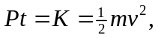 so 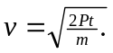
b) 
 